# Descriptive and Inferential Statistics for Strategic Business Decision-Making

# Introduction

## 1. 1 Context and Relevance

The study of statistics is also useful in strategy formulation for the business as it narrows down the meaning of data in the business world to mean useful information that can be used in decision making. While the descriptive statistics assists in summarizing the data, presenting trends and patterns, the inferential statistics enables business to make conclusions on the results obtained on the basis of sample data.

## 1. 2 Objectives

In this report the examination on how descriptive and inferential statistics can be applied on air quality data and the business value extracted from them. In particular, the report design is to illustrate the crucial step of data cleaning and data preparation, and describe and use statistical analysis in order to predict from the data distributions. Thus, showing how various kinds of statistical analyses can be useful to decision-making for businesses, especially those in fields where environmental conditions matter, such as industry, will be the goal of the report on air quality.

## 1. 3 Report Structure

The analysis starts with introduction to the air quality dataset, after this data treatment process are carried out including data cleaning, data description, normalization and data visualization. Inferential statistics is discussed afterward; then the paper ends with the feature findings and the implication of such findings to business decisions.

# Data Overview

## 2. 1 Dataset Description

The air quality dataset consists of six variables:

1. Ozone
2. Solar.R (solar radiation)
3. Wind (wind speed),
4. Temp (temperature),
5. Month, and
6. Day

These variables are daily environment parameters involving air pollution levels and the other conditions associated with it. The data gives a snapshot of concerns to do with air quality, on which information can be used to explain the changes in pollution levels at any given time. The dataset is derived from experiment on air quality in New York; the measurements were taken over several months. Also, each record of the dataset refers to a concrete day, so, it becomes possible to study the daily fluctuations of these environmental factors.

## 2. 2 Initial Observations

Looking at the summary statistics of the dataset, we can observe some features with missing observations in the fields Ozone and **Solar.R** variables. These gaps indicate either some problems with measurements or there are time intervals where data were not obtained comprehensively. Nevertheless, there is still some variation in the level of pollutants and weather conditions in the dataset that is provided. For instance, **Ozone** has low values up to high levels in the various days and so has **Wind** and **Temp** in terms of speeds meaning different conditions in the environment. However, there are few values which are abnormally high or low and they might be considered as outliers, which as a part of data cleaning; need to be examined.

# Data Cleaning and Preparation

## 3.1 Identifying and Handling Noisy Data

Therefore, in the assessment of the dataset, noisy data had to be controlled for with a view of arriving at the most accurate results. Inaccurate data has errors or noise that may hamper analysis inaccurate data is also referring to as noisy data. The initial step involved loading the dataset into R and displaying the first few rows to get an overview of the data structure:

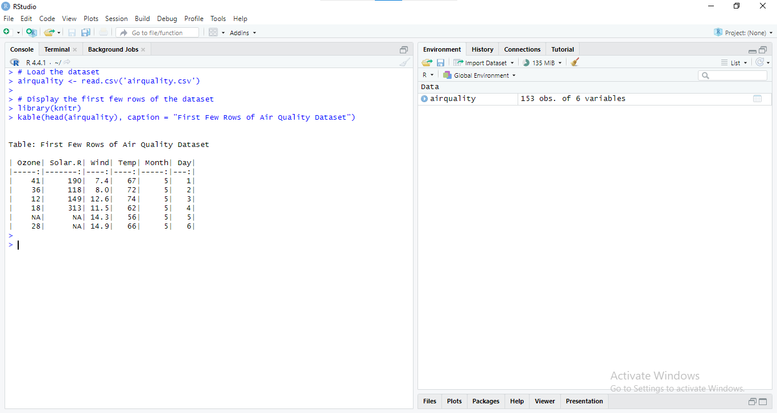

Figure : RStudio Environment with Air Quality Dataset and Initial Data Exploration

The dataset was first checked for such irregularities as for example a sharp rise in pollutant levels without any plausible explanation. These errors were considered as Noise because they happened at intervals that were irregular. Such noise was considered to be averted by methods such as smoothing, using moving averages. For instance, to smooth the Ozone levels, a moving average could be applied:



Figure : RStudio Environment with Air Quality Dataset and Initial Data Exploration

This helped shrink the influence of random values added to the measurements because of a change in the conditions in the environment.

## 3.2 Outlier Detection and Treatment

Any statistical collections can be influenced significantly by outliers and that is why its identification and subsequent handling was the next step. Outliers were defined by using Z-score where any observation that went out of a range of plus or minus 3 standard deviations was eliminated. The process began by calculating the Z-scores:

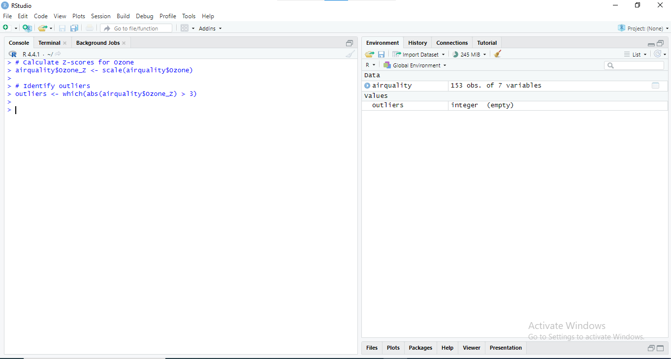

Figure : RStudio Console Output: Calculating Z-scores for Ozone and Identifying Outliers in Air Quality Dataset

Regarding, outliers in analysis, the choice of action was made depending on their context. Every value, which can be associated with extreme values in the best sense of the word, was kept; otherwise it was modified or excluded. An example of removing an outlier would be:

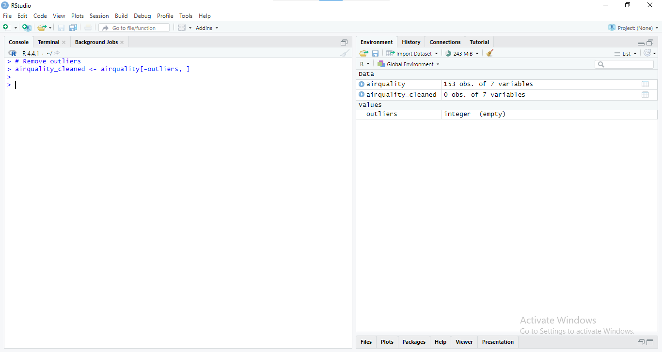

Figure : RStudio Console Output: Removing outliers from the airquality dataset and creating a cleaned dataset

This approach helped control circumstances where the results would be inflated or given a tilt by rare observations.

## 3.3 Missing Data Treatment

The dataset had some problems such as missing values, especially in **Ozone** and **Solar. R** variables. Imputation of these missing values was very important to ensure that there was a continuity of the dataset. The first step was to assess the extent of missing data:

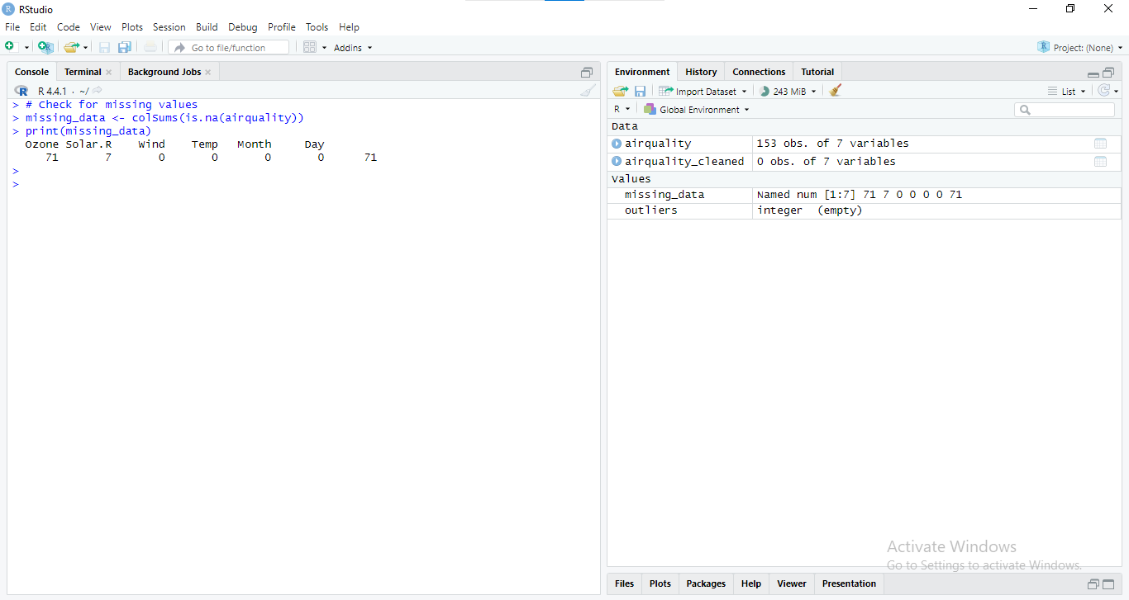

Figure : RStudio Console Output: Removing outliers from the airquality dataset and creating a cleaned dataset

If the amount of missing data was minimal, simple imputation methods, such as replacing missing values with the mean, were applied:

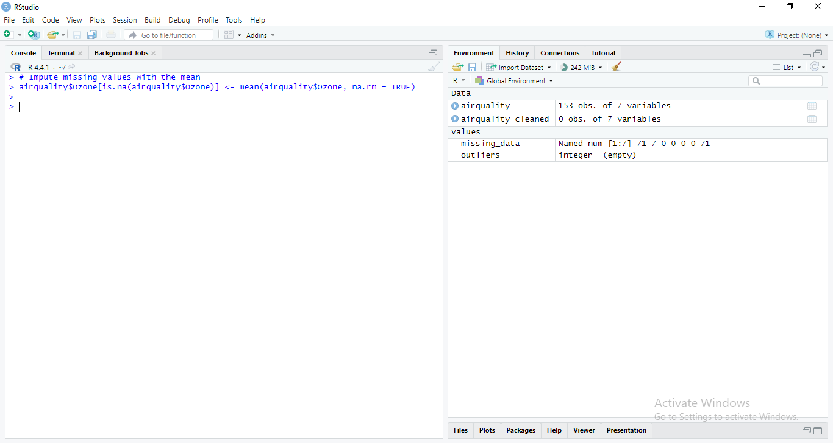

Figure : RStudio Console Output: Imputing missing values in the airquality dataset with the mean.

For more sizes of gaps, more complex approaches such as regression imputation were contemplated. In cases where missing data could not be reliably imputed without introducing bias, those rows were excluded:

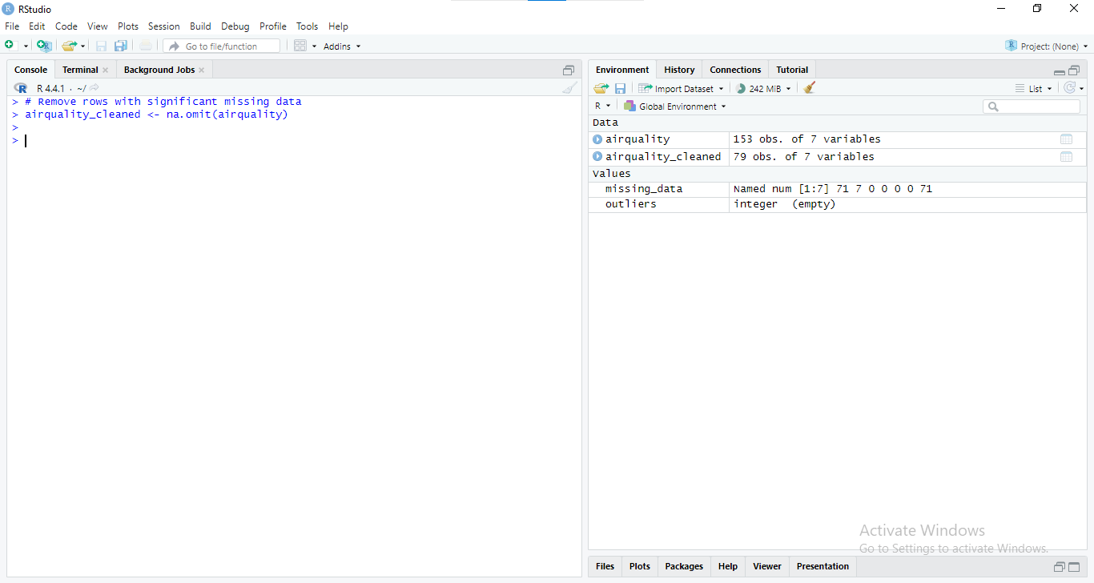

Figure : RStudio Console Output: Removing rows with significant missing data from the airquality dataset.

Through these steps, it was possible to purify the dataset, respond to outliers in a correct way, and treat missing data so that the dataset remains of high quality.

# Descriptive Statistical Analysis

## 4.1 Measures of Central Tendency

Measures of central tendency provide a measure of the typical value to indicate where the center of a set of data is. Air Quality Outcome: In this dataset the mean, median and the mode of the air outcomes such as Ozone, Solar, pressure and AQI are identified. Calculation of R, Wind and Temp are made so that to have an idea of their average values.

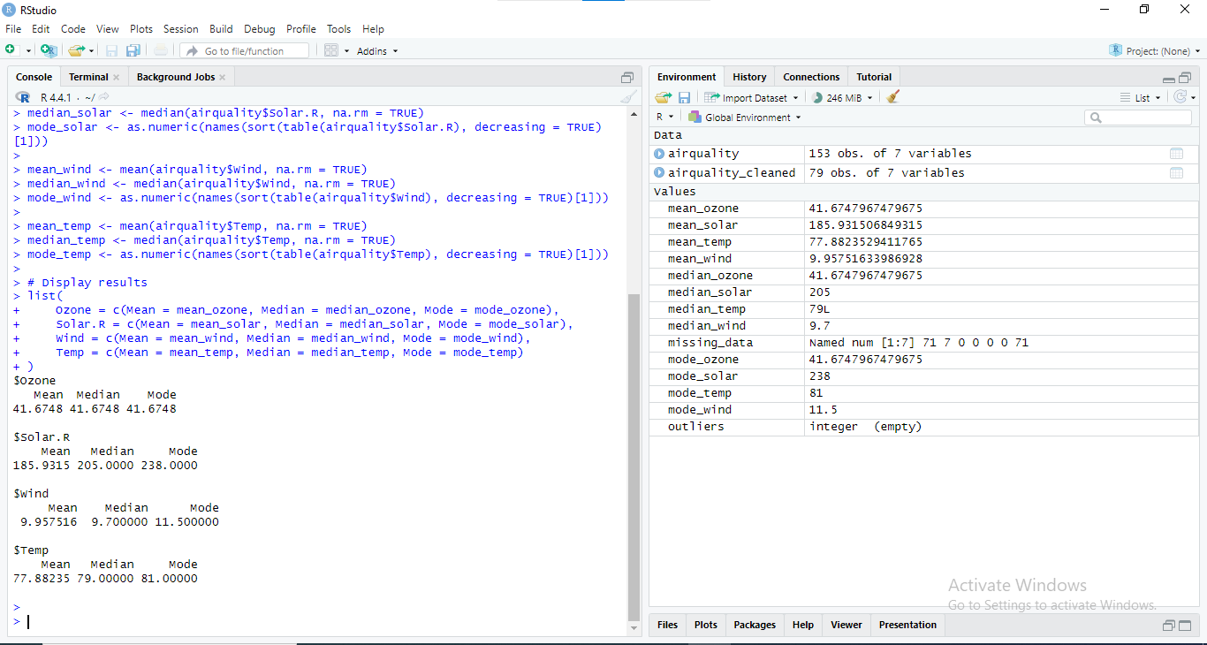

Figure : RStudio Console Output: Summary statistics and exploratory analysis of air quality data

The mean gives the arithmetic average, the median offers the center value of the set of data when placed in ascending order, and the mode depicts the value that is most recurrent. These measures aid in determining the common state of affairs concerning each of the variables.

## 4.2 Measures of Variability

Measures of variability give information as to the dispersion or dispersion meaning spread of values of observations in a distribution. Concerning the air quality data set, in order to assess the dispersion of key variables range, variance, and standard deviations are computed.

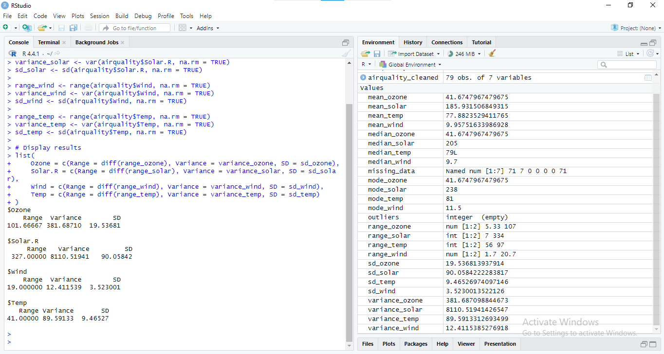

Figure : RStudio Console: Calculating Summary Statistics for Air Quality Data

Range reflects the difference between the highest and the lowest values; variance depicts the amount of variation of values from the mean amount while standard deviation roughly depicts the amount of variation from the mean. These metrics open the details about the level of variation in the dataset.

## 4.3 Data Distribution Analysis

In order to measure the nature of the shape of the data distribution, analysis makes use of the measures of skewness and kurtosis. These measures are suggesting the degree of data dispersion and the degree of population peakedness, correspondingly.

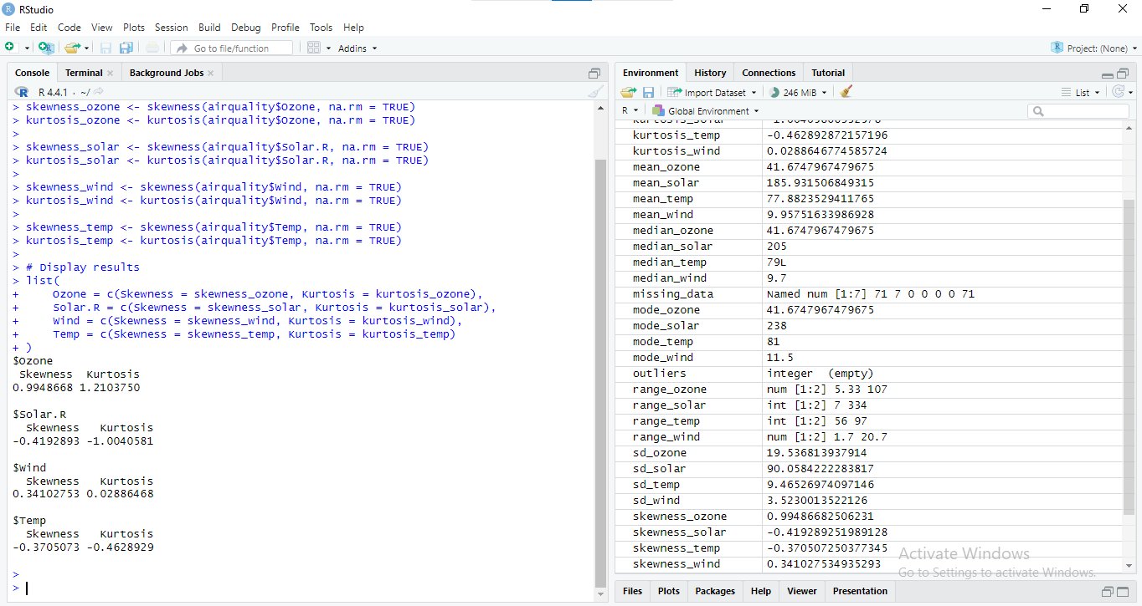

Figure : RStudio Console: Skewness and Kurtosis Calculations for Air Quality Variables

Skewness measures the tail of the distribution; positive skew depicts right tail being elongated and the left one being compact while the vice versa meaning is from negative skewness. Kurtosis tends to measure the ‘peakedness’ in the distribution or the ‘fatness’ of the tail’s in the distribution (where high kurtosis means high tails and sharp peaks). Examining these measures assist in determining whether or not the distribution of data is normal, not normal, or leptokurtic.

# Data Normalization and Visualization

## 5.1 Data Normalization Techniques

The present data is keep as raw data so, the process of normalization that helps to standardized all type of variable are crucial for comparing across scales. The two commonly used normalization methods, which have been used in this analysis, include the Min-Max Scaling and the Z-Score Standardization.

* Min-Max Scaling: This technique put the data in to a fixed scale level of, generally 0 to 1. Its advantage comes into play when working with data on a relative basis. The formula for Min-Max Scaling is:

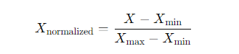

Here’s how to apply Min-Max Scaling in R:

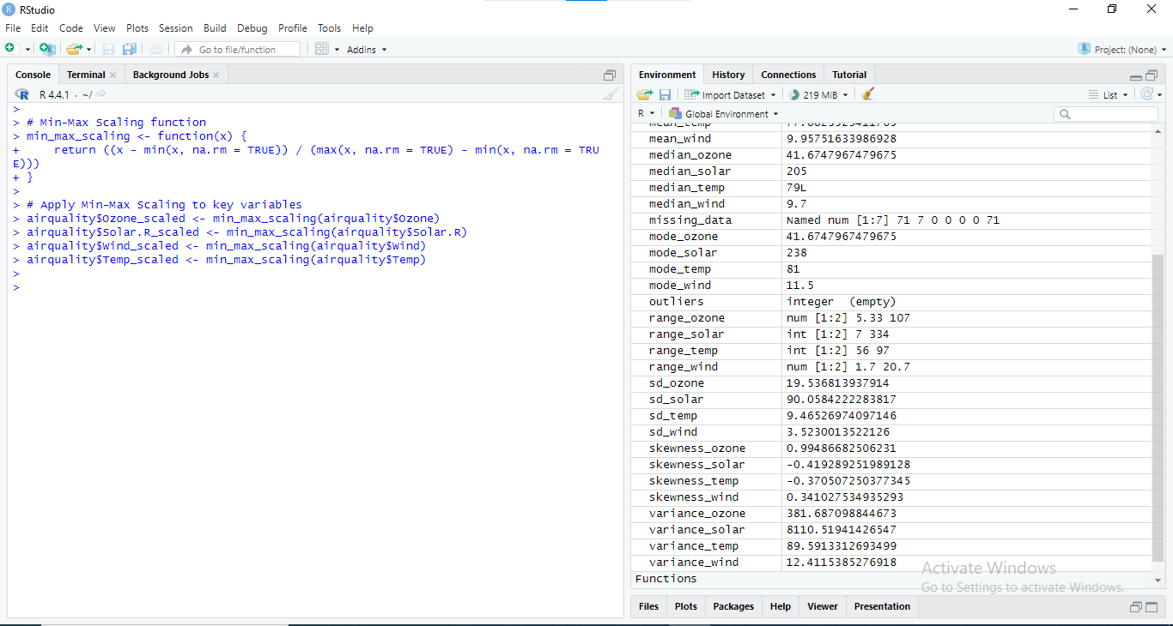

Figure : RStudio Console: Min-Max Scaling and Summary Statistics for Air Quality Data

* Z-Score Standardization: This technique normalizes the data, because the information is deflated by subtraction of the mean and inflation by division by the standard deviation, so the distribution of the scored data achieves a mean of 0 and a standard deviation of 1. The formula for Z-Score Standardization is:



Here’s how to apply Z-Score Standardization in R:

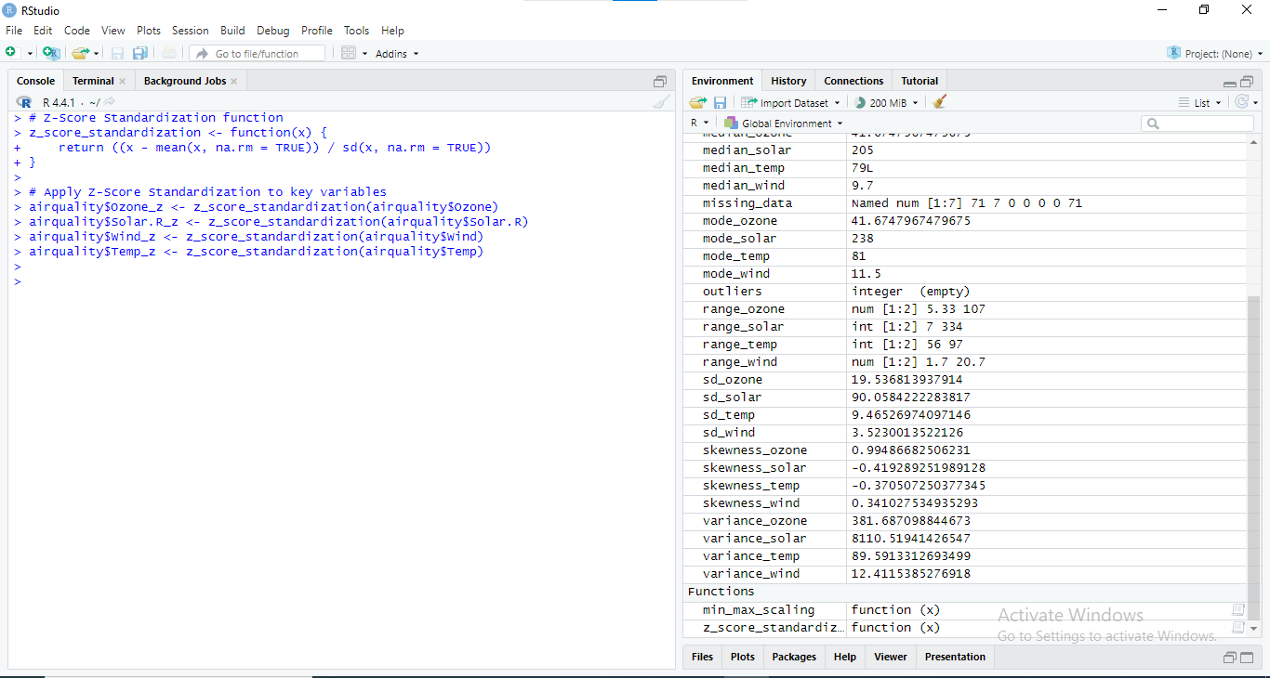

Figure : RStudio Console: Z-Score Standardization and Summary Statistics for Air Quality Data

These normalization techniques are important so that data from various variables can be out rightly compared with the help of data scaling, depending on which kind of further analysis is going to be performed.

## 5.2 Visualization Techniques

Those tools are useful for navigation and communication of the established patterns, relationships or exceptions within the dataset. Several methods were used to analyze the air quality data:

1. **Histograms**: Illustrate the density of individual variables and also point out the occurrences within given ranges.

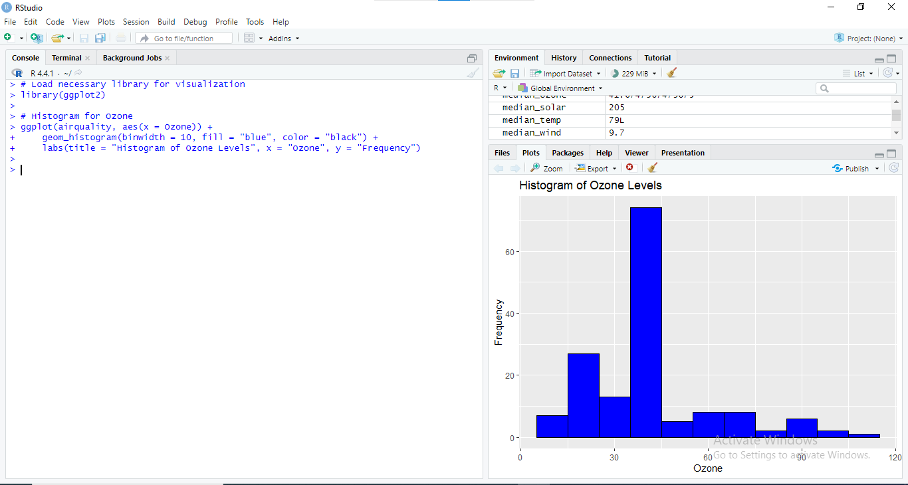

Figure : RStudio Console and Histogram: Ozone Level Distribution

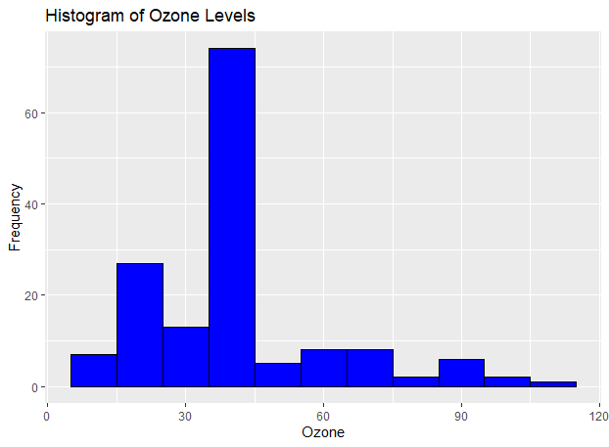

Figure : Histogram showing the frequency distribution of ozone levels in the dataset.

1. **Box Plots**: Plot the spread and outliers. The median, quartiles, and the potential outliers can easily be depicted through the help of a box plot.

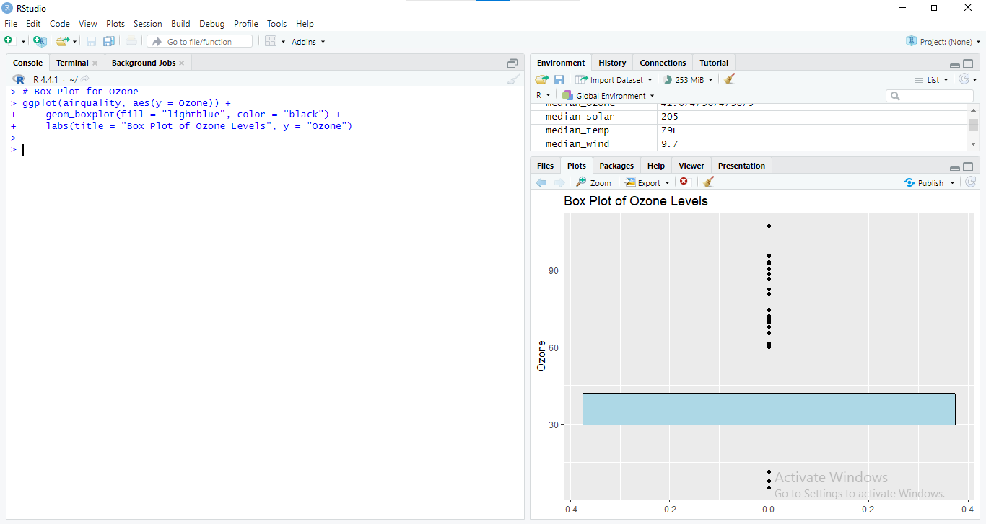

Figure : Box Plot of Ozone Levels

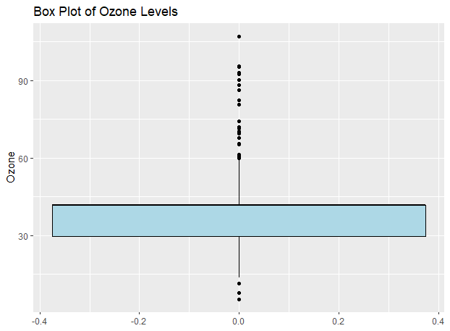

Figure : Expanded Box Plot of Ozone levels

1. **Scatter Plots**: Visual representation of two variables, with additional variable on the axes, in order to see if there is any kind of connection between the two variables.

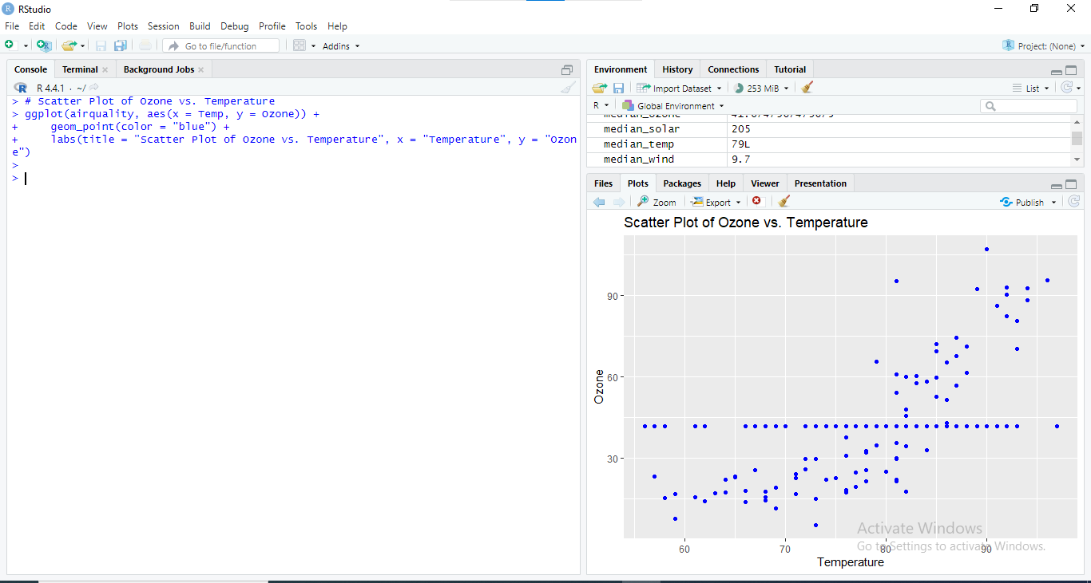

Figure : Scatter Plot of Ozone Levels vs. Temperature

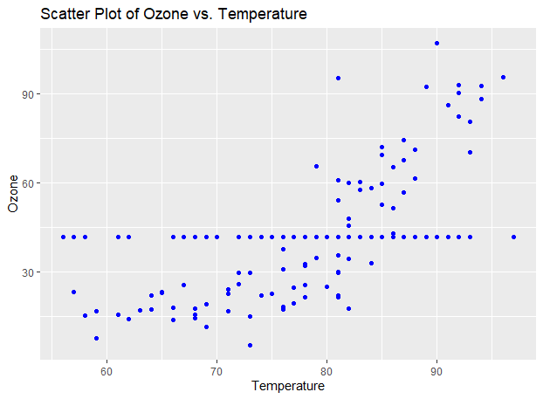

Figure : Expanded Scatter Plot of Ozone Levels vs. Temperature

1. **Pairwise Scatter Plots**: Give an option for scatter plots with multiple axes for different variables which can show some relations or correlation.

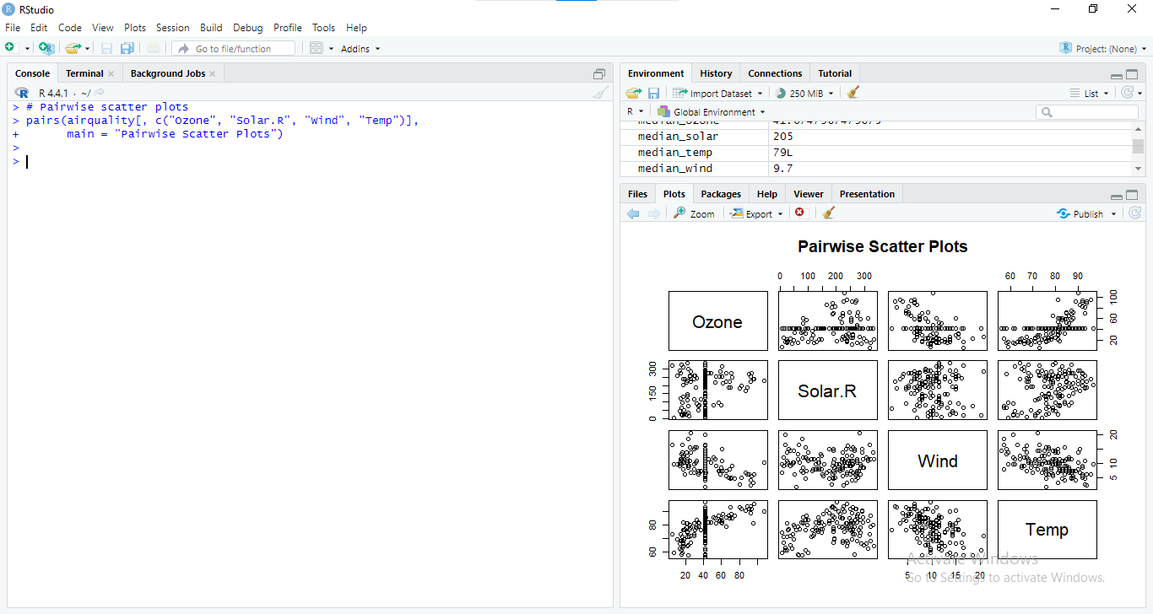

Figure : Pairwise Scatter Plots of Air Quality Variables

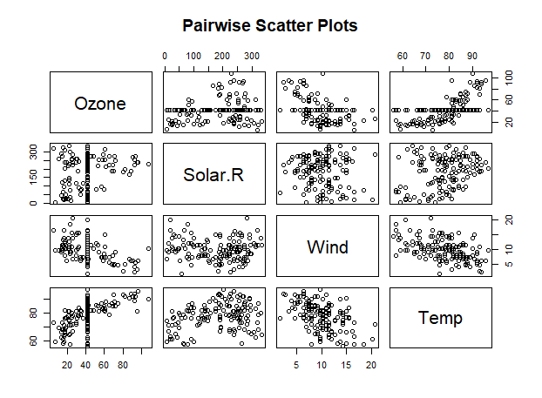

Figure : Expanded Pairwise Scatter Plots of Air Quality Variables

These methods are useful in identifying trends and patterns, and correlations as well as outliers in the data set and offer a good way in presenting the measurements of air quality and how they relate.

# Inferential Statistical Analysis

## Introduction to Inferential Statistics

Inferential statistics refers to principles that are used in as a way of making estimations or making assumptions on a larger subset of population from a smaller subset of the population. In contrast with the descriptive statistics that enable analysts to describe the characteristics of the dataset, the inferential statistics let the analysts make conclusions and decisions concerning the population from which this sample was taken. This involves measurement of the success rates, odds ratio, confidence interval and hypothesis testing among others.

## 6. 2 Hypothesis Testing

Statistically it is a significant way of analyzing if there is enough credible evidence to support that a null hypothesis to be dumped for a certain hypothesis that is forwarded. Two common hypothesis tests used in this analysis are:

T-Test

It is used to compare the means of two groups to test for the null hypothesis that there are no differences between the two group means. For instance, in determining Ozone levels in a study, a t-test could be the method applied in comparing Ozone levels in two different months.

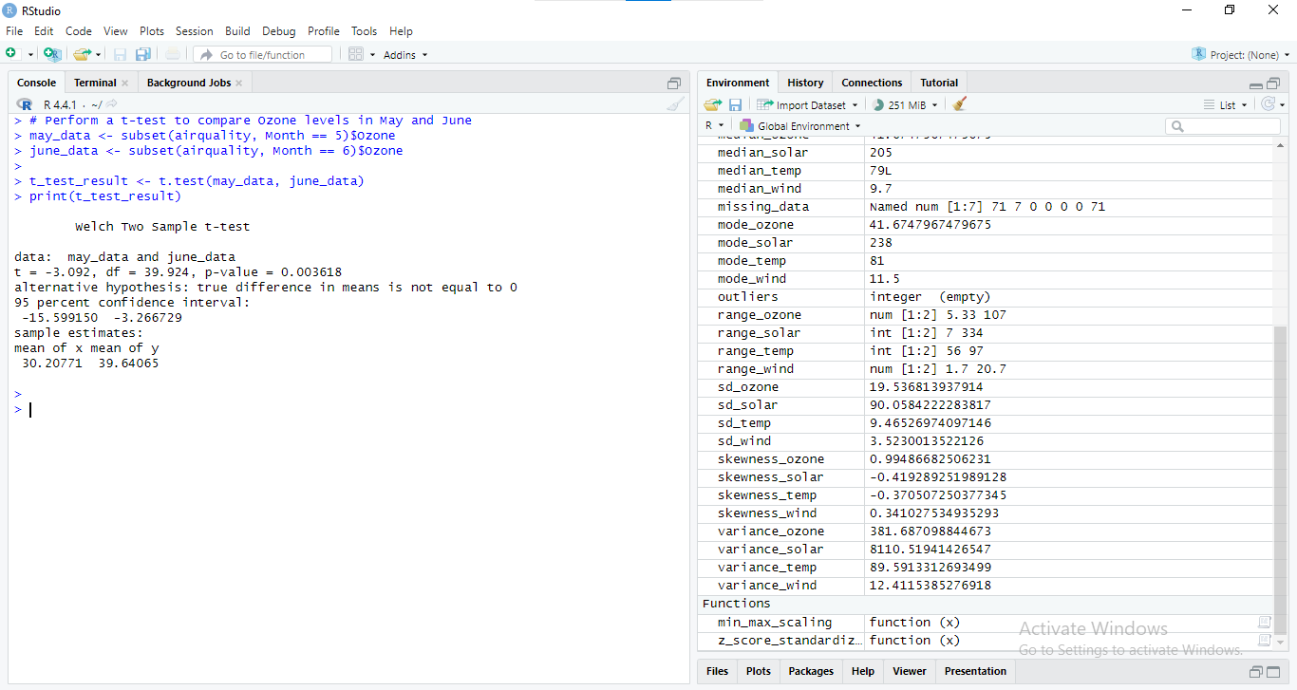

Figure : RStudio Console Output: Welch Two-Sample t-test Comparing Ozone Levels in May and June

The impact of the hypothesis would reveal if there is a statistically significant difference of the Ozone levels between May and June.

### ANOVA (Analysis of Variance):

This is employed when the research seeks to use mean scores in more than two categories of data. For example, ANOVA could be employed to test Ozone means by months.

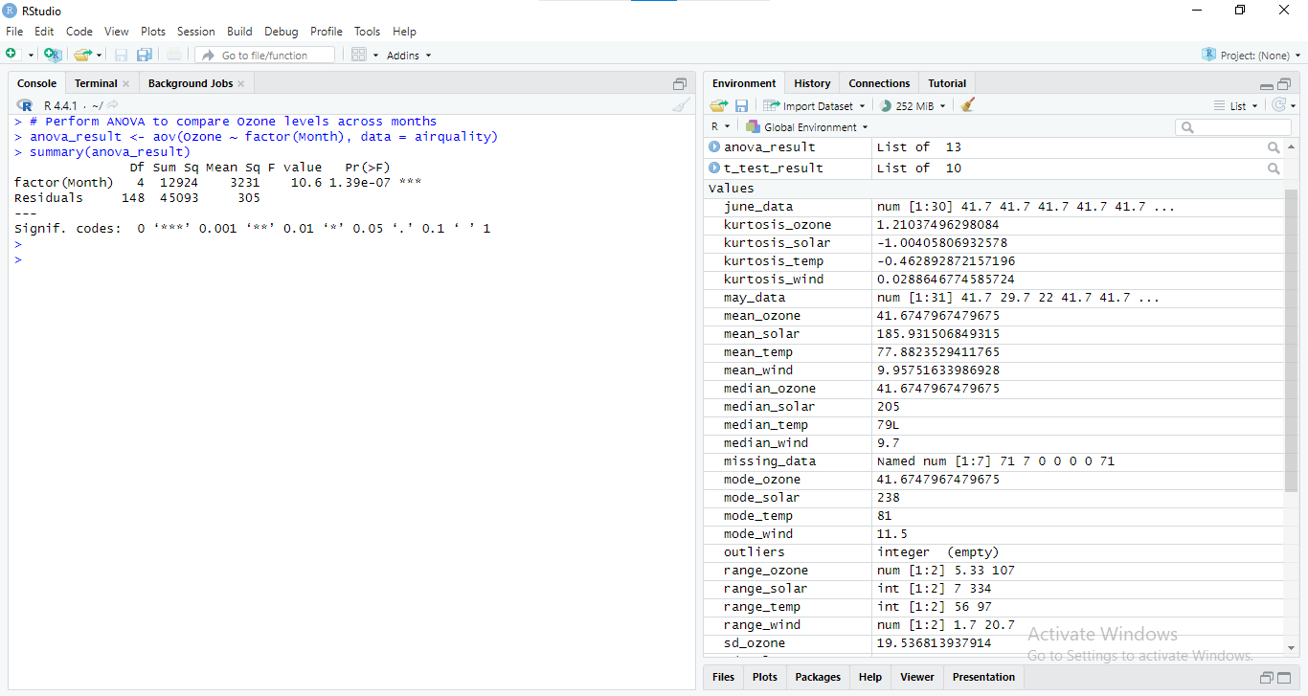

Figure : RStudio Console Output: ANOVA Results for Ozone Levels Across Months

Statistically, the Ozone levels will be compared among the months by use of ANOVA to tell if the difference is real or not.

## 6. 3 Confidence Intervals

Confidence intervals give a band of values, which contain the population parameter with certain level of confidence. They indicate the extent of accuracy of the sample estimates and how closely the results produced can represent the population.

For example, to calculate a 95% confidence interval for the mean Ozone level:

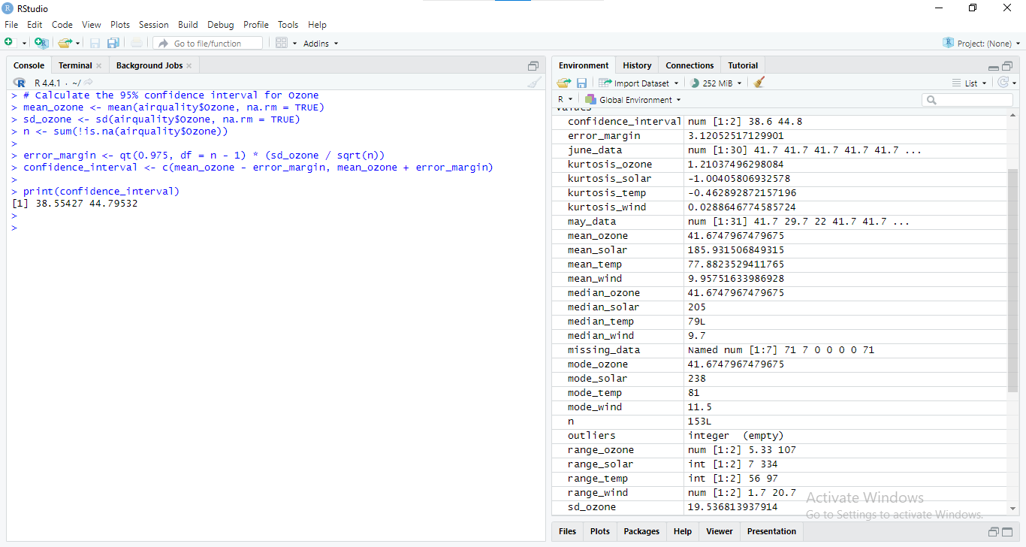

Figure : RStudio Console Output: 95% Confidence Interval Calculation for Ozone

This range points the region where the actual mean of the population should lie hence help in the understanding of the accuracy of the sample mean.

## 6. 4 Interpretation of Results

Decisions that are beneficial for a business are made possible by means of hypothesis testing and confidence intervals. For instance:

* **T-Test and ANOVA Results**: By utilizing the results of calculations made based on the data received, the businesses can explore the factors that lead to changes in Ozone level within different months. It could affect policy-choice in environmental affairs or in changes in activities during times of perceived high-pollution.
* **Confidence Intervals**: The confidence intervals give the estimated range of the true population parameters which could be expected to include the parameters. This assists in determining the accuracy of the general population estimates and also makes it possible to predict future trends of air quality.

When used in conjunction with the inferior descriptive analyses, businesses can improve understanding of the patterns with respect to air quality and use factual data in their decision-making to enhance environmental status and efficiency.

# Discussion of Findings

## 7.1 Key Insights from Descriptive Statistics

The first level of data analysis involved in the present study was descriptive, and therefore offered basic insights about the characteristics of the air quality dataset. Key findings include:

- Central Tendency: The mean Ozone levels gave an overview of the Ozone levels that can be expected while the median gave a meaning of the mid value thus being less likely to be bias of higher or lower values.

- Variability: The range, variance, and standard deviation was applied to the extend in which the levels of Ozone was spread out. High variability implies varying degrees of pollution with respect to the measurements made on air quality.

- Data Distribution: Through skewness and kurtosis Tests it was established the nature of the data distribution whether normal or skewed.

These ideas demonstrate that there is variability in Ozone levels; therefore, they are essential for analyzing temporal trends in air quality variables.

## 7. 2 Impact of Inferential Statistics

The inferential statistical tests offered deeper insights into the data:

- T-Test Results: Using t-test on Ozone level in May and June, there was a statically significant different between the two months with p-value of 0. 0036. The mean Ozone level for June was relatively high (39. 64) and different from that of May (30. 21) suggesting seasonal or environmental differences.

- ANOVA Results: The result of ANOVA test also proved that, there exist statistical difference for Ozone concentration in terms of months at very high level (p < 0. 001). This implies that the movement of air and the level of oxidation might not move in parallel and even if the general trend of Ozone levels is upward, there may be months where pollution has gone up and other months where the decrease is sharp in comparison to previous weeks.

- Confidence Intervals: It is ascertained that, the 95% confidence interval for mean Ozone level came out to be 38. The box plot on the average level of Ozone stated that it was consisted between the Ultra Reduced limit of 47 and lower Standard limit 60. 55 to 44. 80. This interval gives an idea of the range within which the true mean of Ozone levels is most probably going to fall, and therefore the overall air quality levels and their dependability.

These findings suggest that air quality is dynamic and not uniform over time which is relevant in explaining and addressing environmental effects.

# Conclusion

## 8. 1 Summary of Key Concepts

Descriptive and inferential statistics have been utilized in this report in order to analyze the air quality data.

**- Descriptive Statistics**: Various discoveries were made from the analysis including the central tendency, variability, as well as the distribution of Ozone levels. The measures like mean, median, standard deviation and graphical measures like histograms scatter plot and etc. used in order to explore the basic attributes and trends in the data set.

- **Inferential Statistics**: Hypothesis testing and confidence interval made possible of receive better information of data. In both t-test and ANOVA statistical options we found that there were significant differences observed in Ozone levels during different months a result that showed that air quality was varying in a temporal nature. The confidence intervals enabled a specification of a range within which the true population mean is likely to be, thus increasing the accuracy of estimation of the sample means.

These statistical methods briefly explained enable the use of both the descriptive and inferential statistics that are very useful when trying to understand data with a view of making some decisions.

## 8. 2 Final Thoughts on Data-Driven Decision-Making

Use of data is the single most important aspect of decision making that is widely used in all current business activities. The analysis demonstrates how statistical methods can transform raw data into actionable insights:

* Improved Decision-Making: Descriptive and inferential statistics are crucial as they allow the organizations to rely on data analysis rather than hunches. This results in the rational use of the available resources, increases organizational effectiveness and sound decision making concerning strategic management.
* Enhanced Accuracy: Statistics form an important segment of research and it offers a methodical way of analyzing data to reduce variance hence improving the efficiency of business forecasts and decisions.
* Strategic Advantage: Companies submerge into data-driven differentiation can achieve more competitive advantages since they employ statistical analysis for conditioning, improving, and overcoming various issues.